**Assignment Module : 1(HTML)**

1. Are the HTML tags and elements the same thing?

→ No. the HTML tags and elements are both different thing.

2. What are tags and attributes in HTML?

→ HTML tags are used to hold the HTML element, while HTML attributes are used to describe the characteristic of an HTML element in details.

3. What are void elements in HTML?

→ HTML elements have a start tag and an end tag that indicates where the element begins and where it ends. There is a group of elements that are exceptions to this rule. These elements are called empty or void elements. They only have start tag since they can’t contain any content.

4. What are HTML Entities?

→ An HTML entity is used to display invisible characters and reserved characters that would otherwise be interpreted as HTML code. It is a piece of text that begins with ampersand (&) and ends with semicolon (;).

5. What are different types of lists in HTML?

→ There are three types of lists in HTML

1. Ordered list
2. Unordered list
3. Description or Definition list

6. What is the ‘class’ attribute in HTML?

→ The class is an attribute which specifies one or more class names for an HTML elements. It is mostly used to points to a class in style sheet.

7. What is the difference between the ‘id’ attribute and the ‘class’ attribute of HTML elements?

→ A Class name can be used by multiple HTML elements, while an ID name must only be used by one HTML element within the page.

8. What are the various formatting tags in HTML?

→ The various formatting tags in HTML are as under.

1. <b> - Bold text

2. <i> - Italic Text

3. <u> - Underlined text

4. <mark> - Marked text

5. <small> - Smaller text

6. <sup> - Superscript text

7. <sub> - Subscript text

9. How is Cell Padding different from Cell Spacing?

→ Cell Spacing provides space between two or more cells, while Cell Padding is used to define the space between cell and content.

10. How can we club two or more rows or columns into a single row or column in an HTML table?

→ It can be done by using the rowspan and colspan attribute in HTML table. A rowspan attribute is used to club two or more rows where a colspan attribute is used to club two or more columns in HTML table.

11. What is the difference between a block-level element and an inline element?

→ A block-level element always starts from a new line and takes up the full width available. An inline element does not start from a new line and it takes up as much width as necessary.

12. How to create a Hyperlink in HTML?

→ The <a> tag defines the hyperlink. The href attribute defines the link address. Anything between this tag becomes the part of the link. We can also use the target attribute to define where to open the linked document.

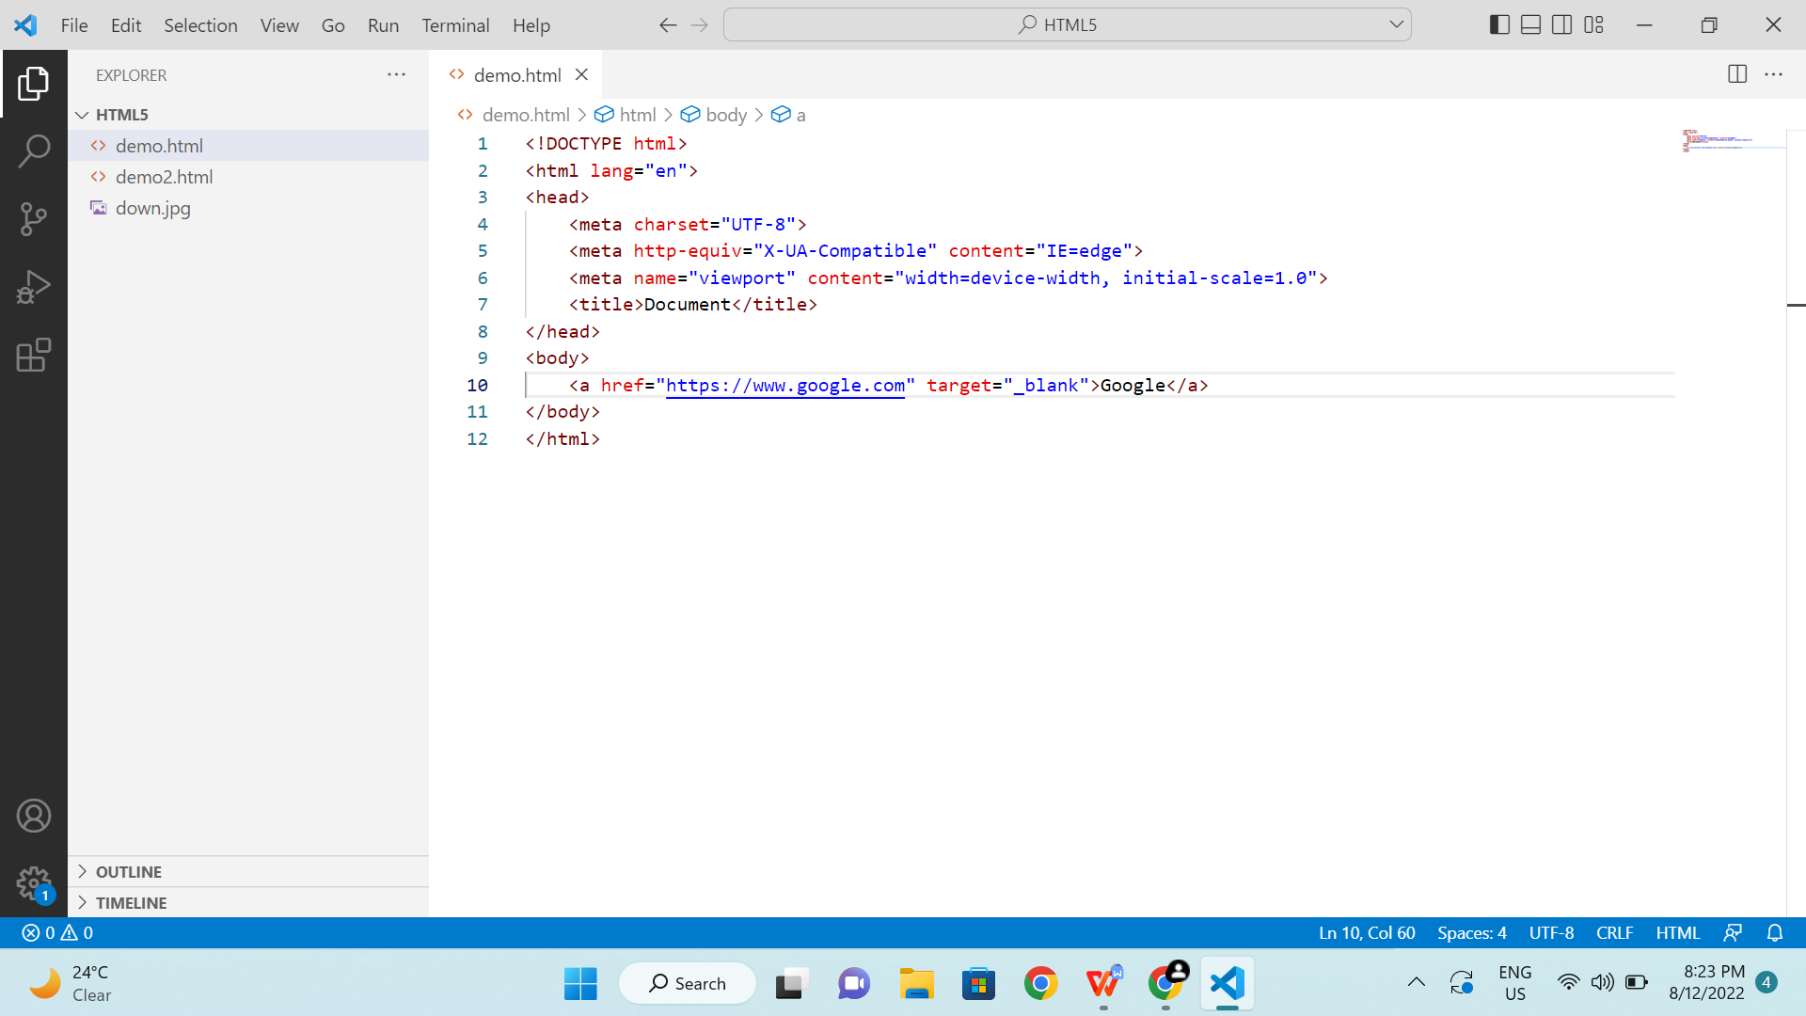

13. What is the use of an iframe tag?

→ The <iframe> tag specifies an inline frame. An inline frame is used to embed another document within the current HTML document.

14. What is the use of a span tag? Explain with example?

→ The <span> tag is an inline container and used to mark up a part of a text or part of a document.

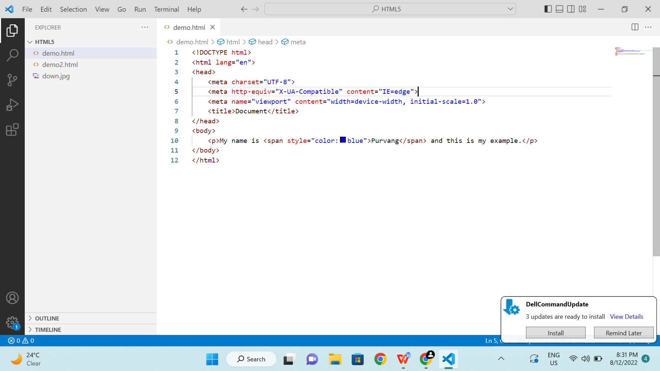

15. How to insert a picture into a background image of a web page?

→ The most common and simple way to add background image is using background image attribute inside the <body> tag.

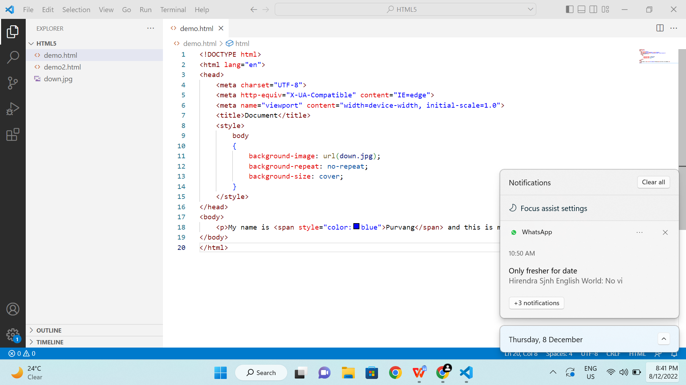

16. How are active links different from normal links?

→ Normal links are links which are those on the page and have not been clicked yet. Active links are those links, which have been just clicked at that instant.

17. What are the different tags to separate sections of text?

→ There are three tags to separate sections of text.

1. <br> tag is used to separate the line of text.
2. <p> tag contains the text in the form of paragraph.
3. <blockquote> tag is used to define a large quoted section.

18. What is SVG?

→ SVG stands for Scalable Vector Graphics. SVG is used to define vector-based graphics for the web. SVG defines the graphics in XML format.

19. What is difference between HTML and XHTML?

→ HTML stands for Hyper Text Markup Language and XHTML stands for EXtensive Hyper Text Markup Language. XHTML is a stricter, more XML-based version of HTML.

→ The most important difference of XHTML from HTML are as under

-<!DOCTYPE> is mandatory.

-The xmlns attributes in <html> is mandatory.

-<html>,<head>, <title> and <body> are mandatory.

-Elements must always be properly nested, closed and in lowercase.

-Attributes name must always be in lowercase.

-Attributes values must always be quoted.

-Attribute minimization is forbidden.

-

20. What are logical and physical tags in HTML?

→ Logical tags are used in HTML to display the text according to the logical styles, while Physical tags are used in HTML to provide actual physical formatting to the text.